Event Handling #1 complete overvie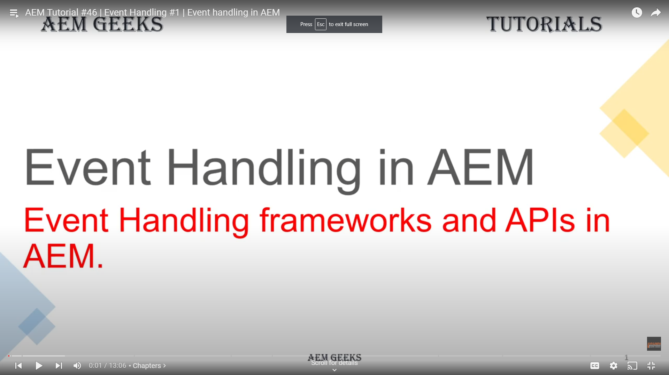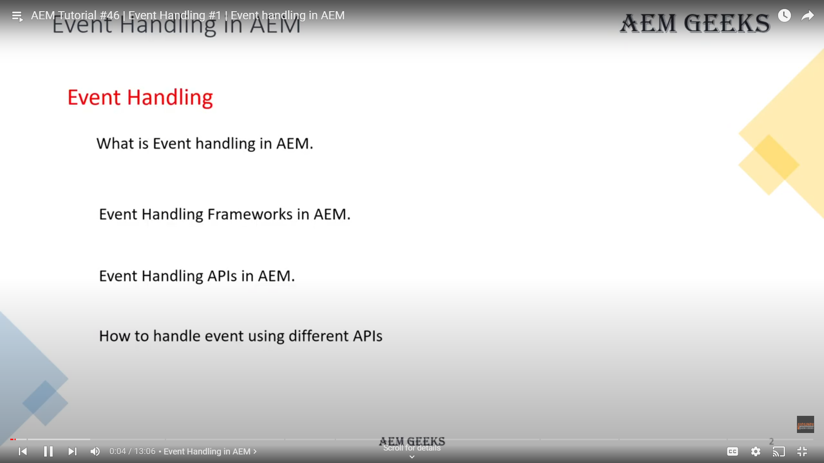 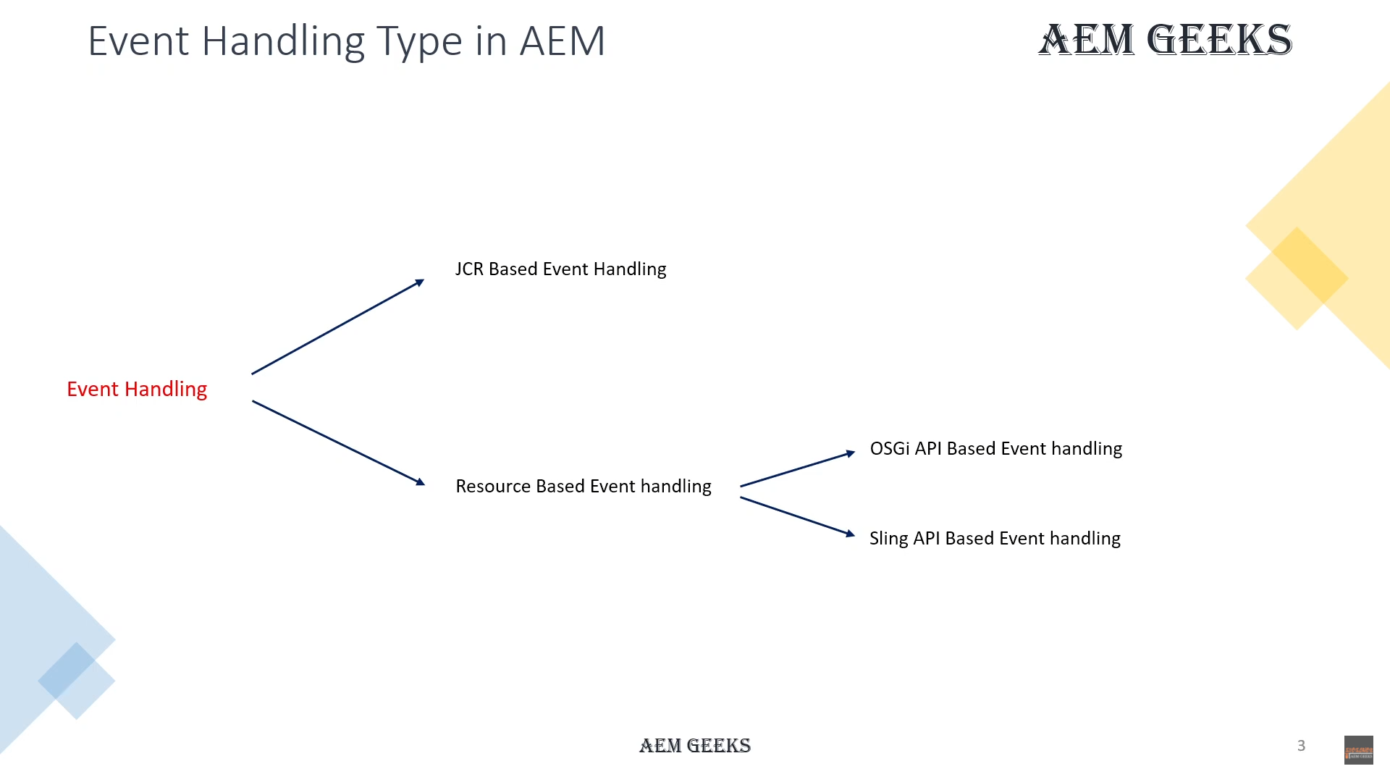 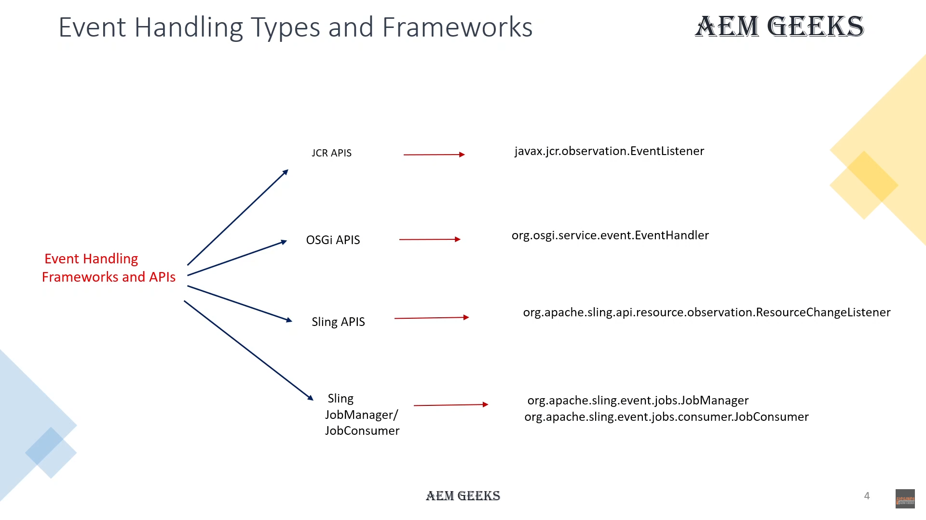 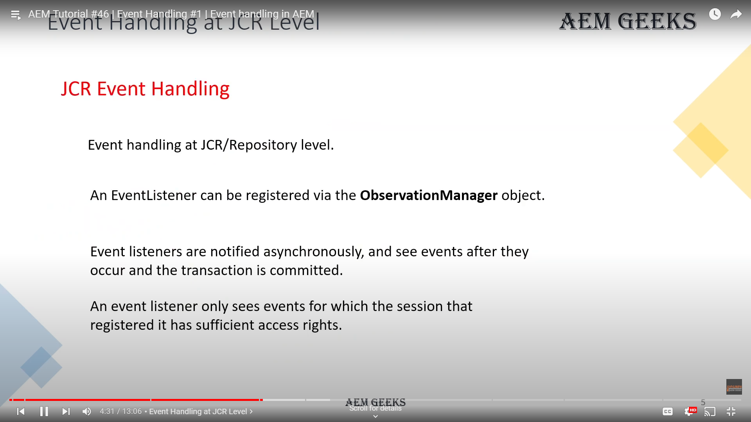 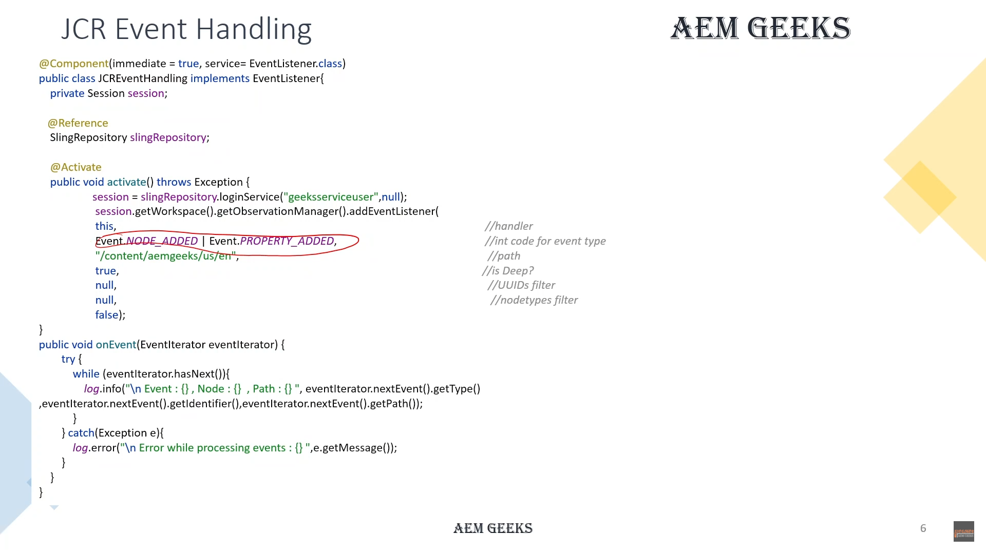 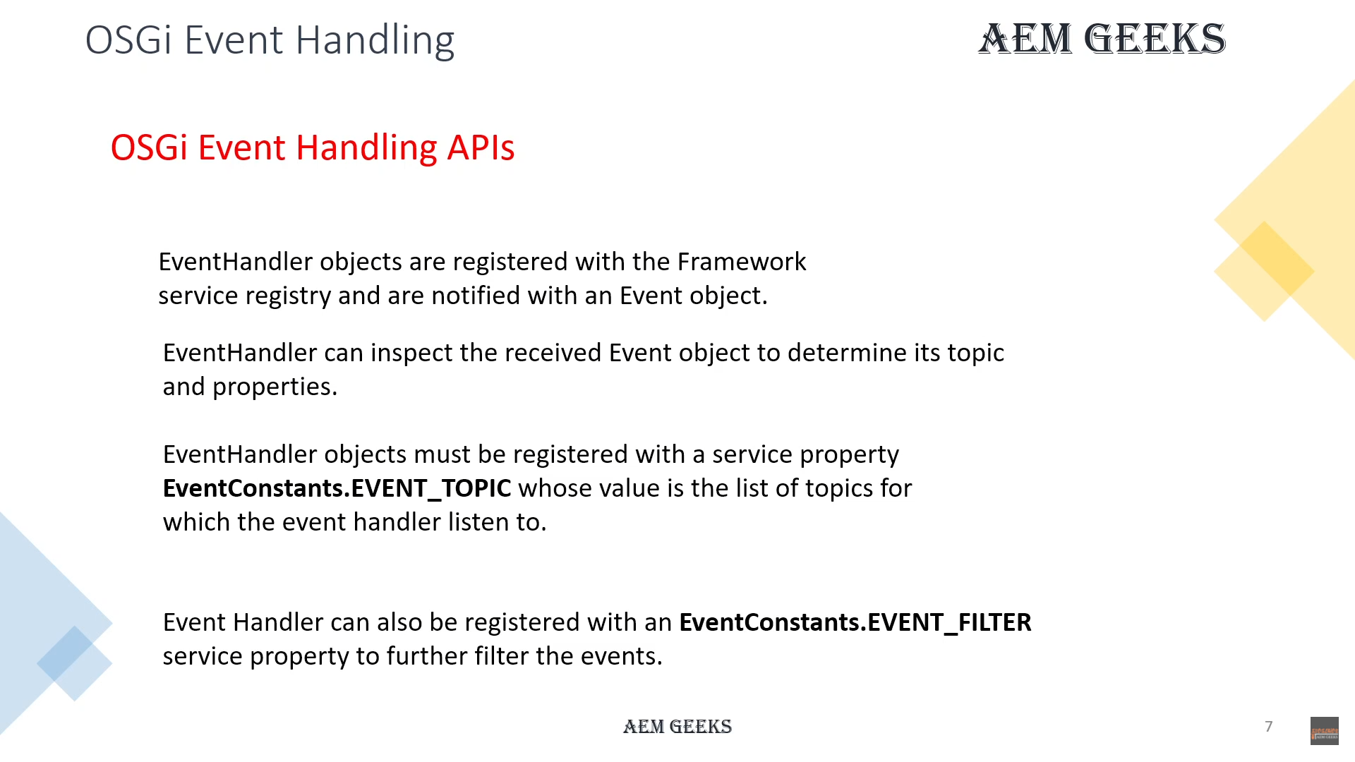 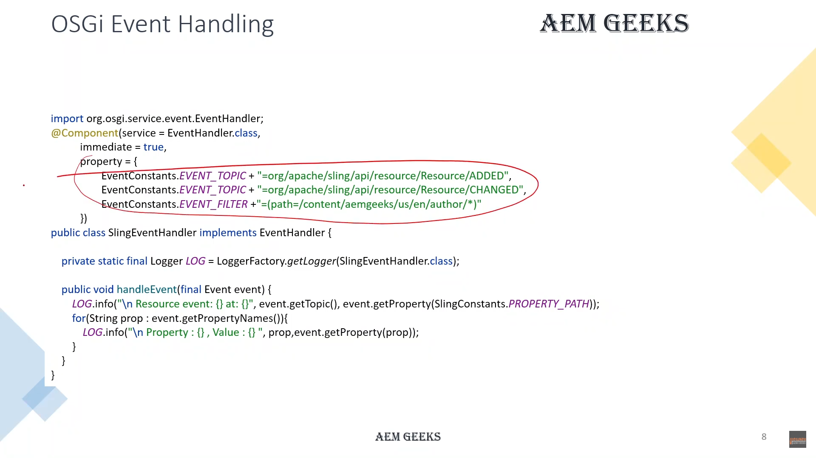 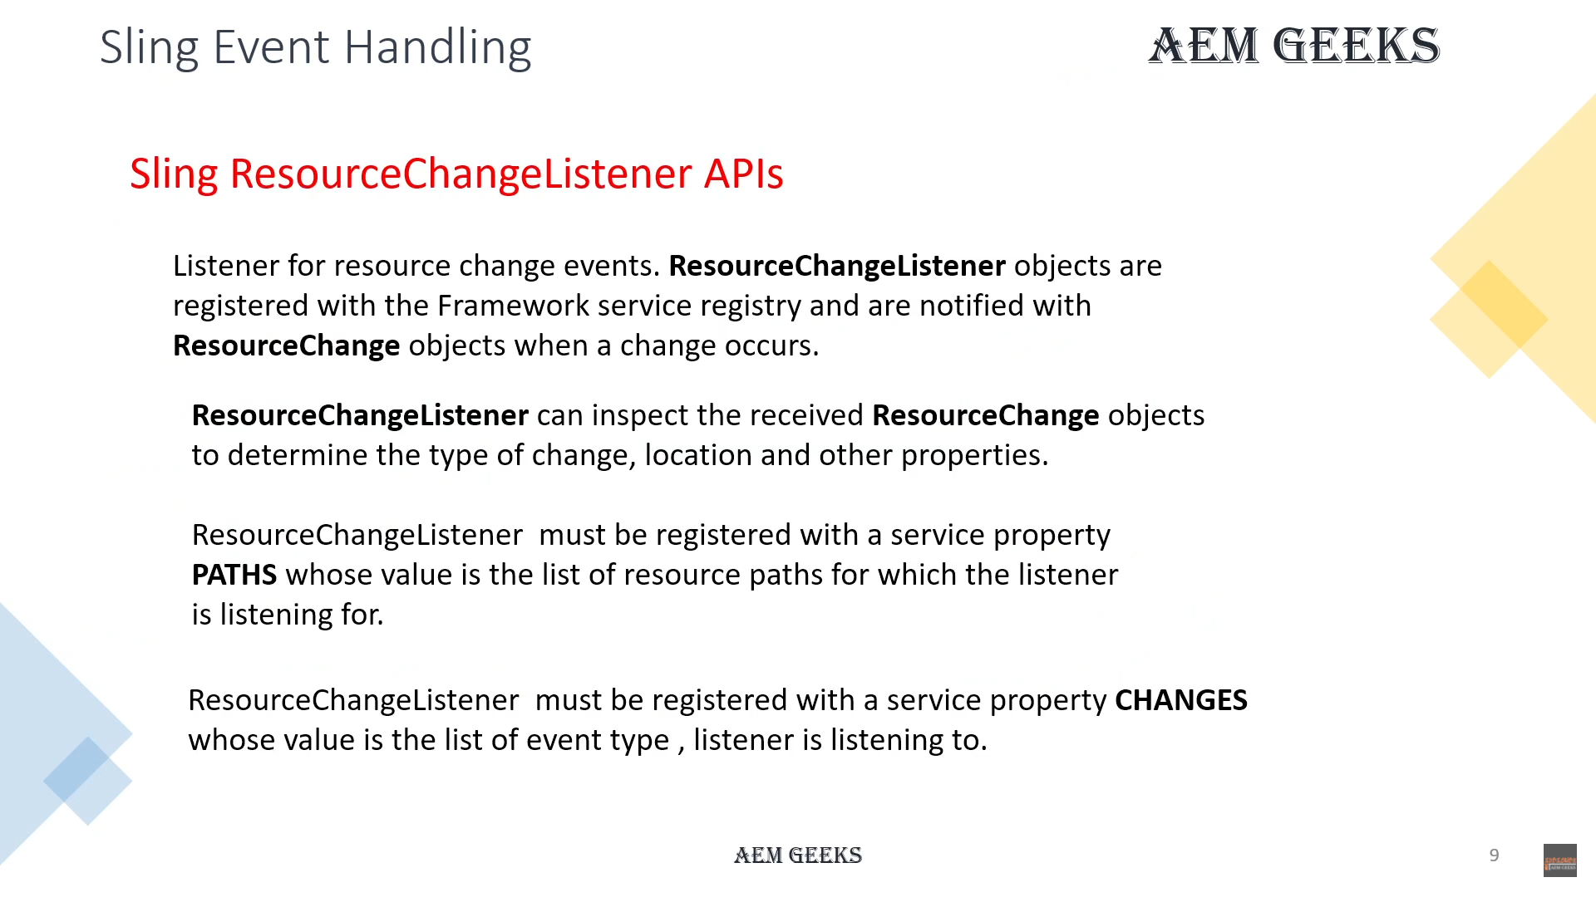 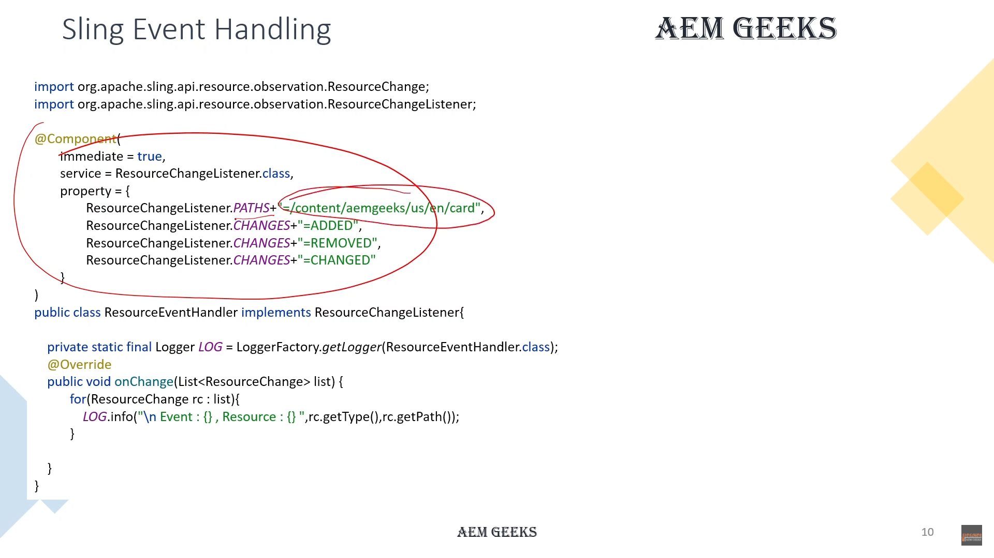 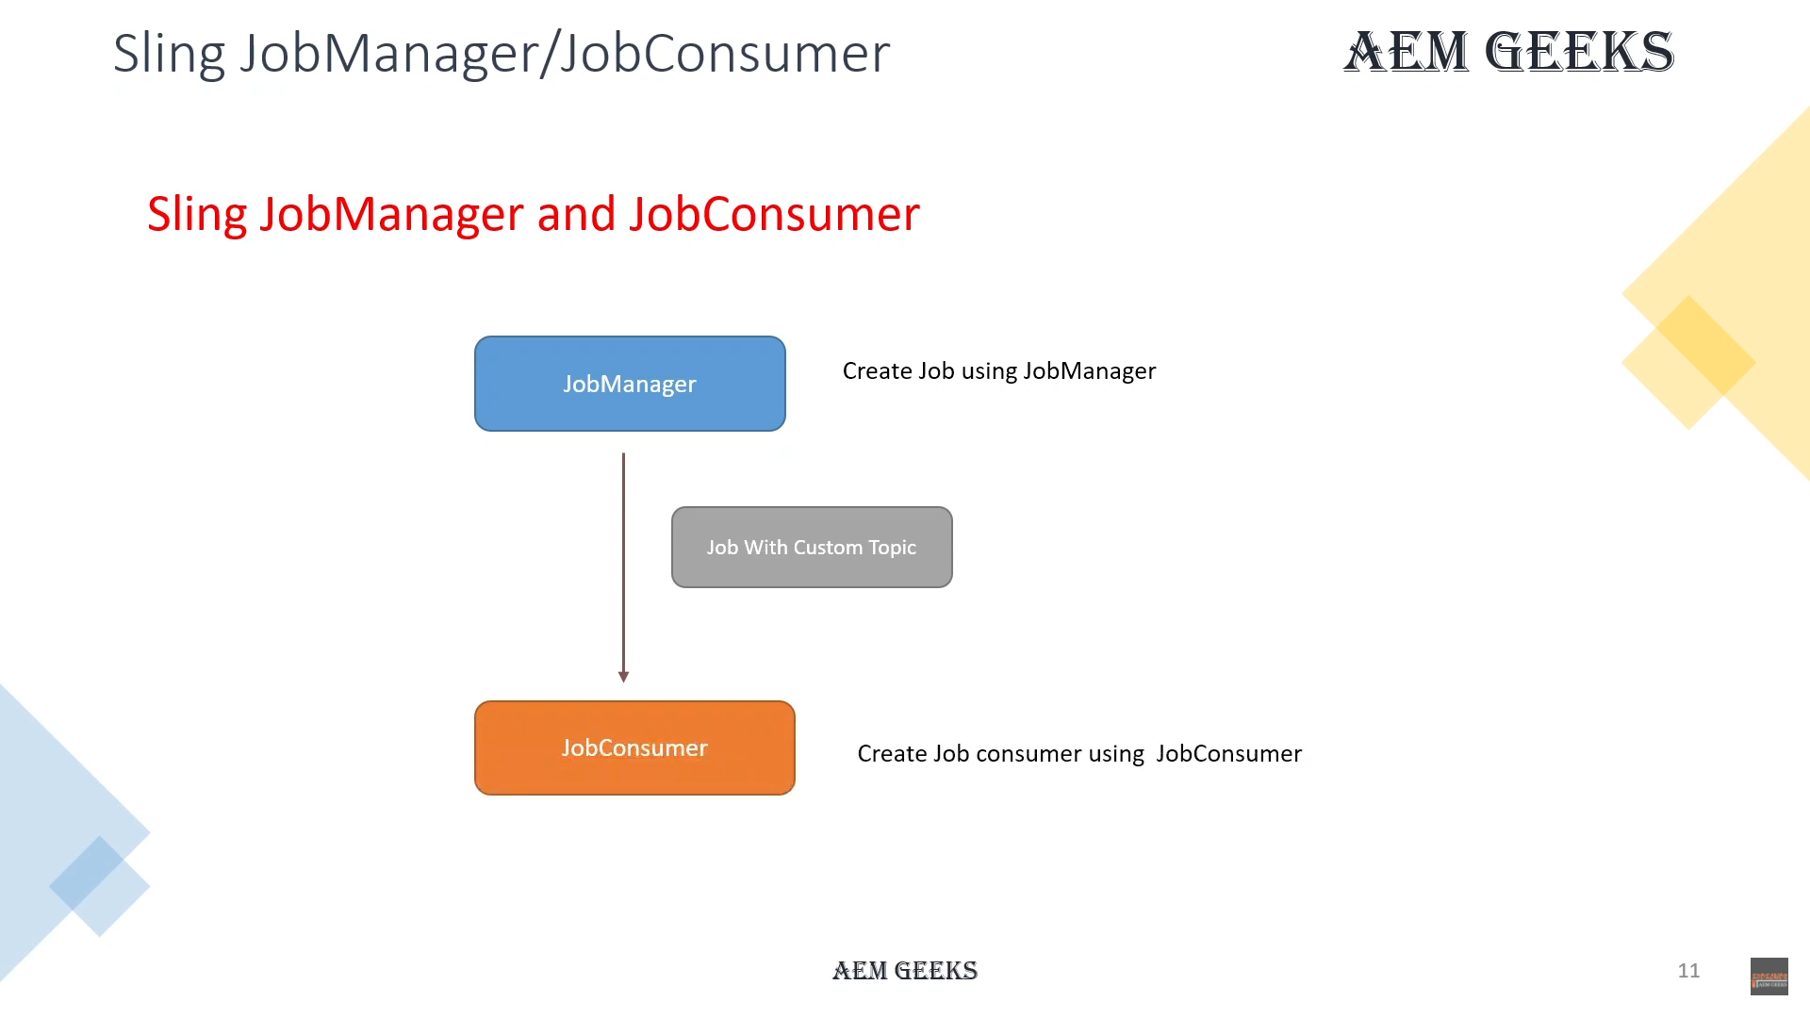 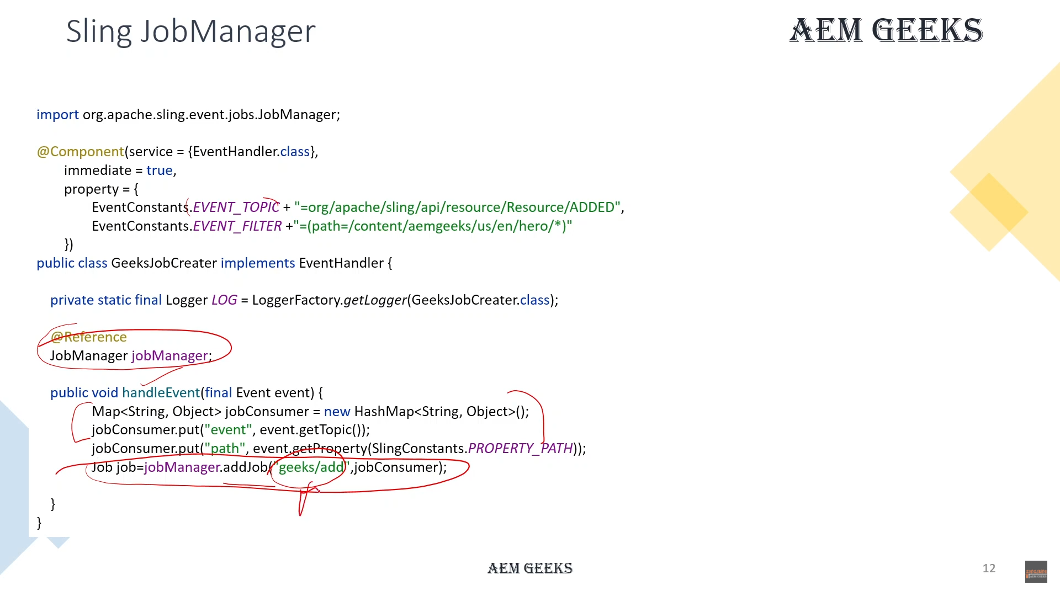 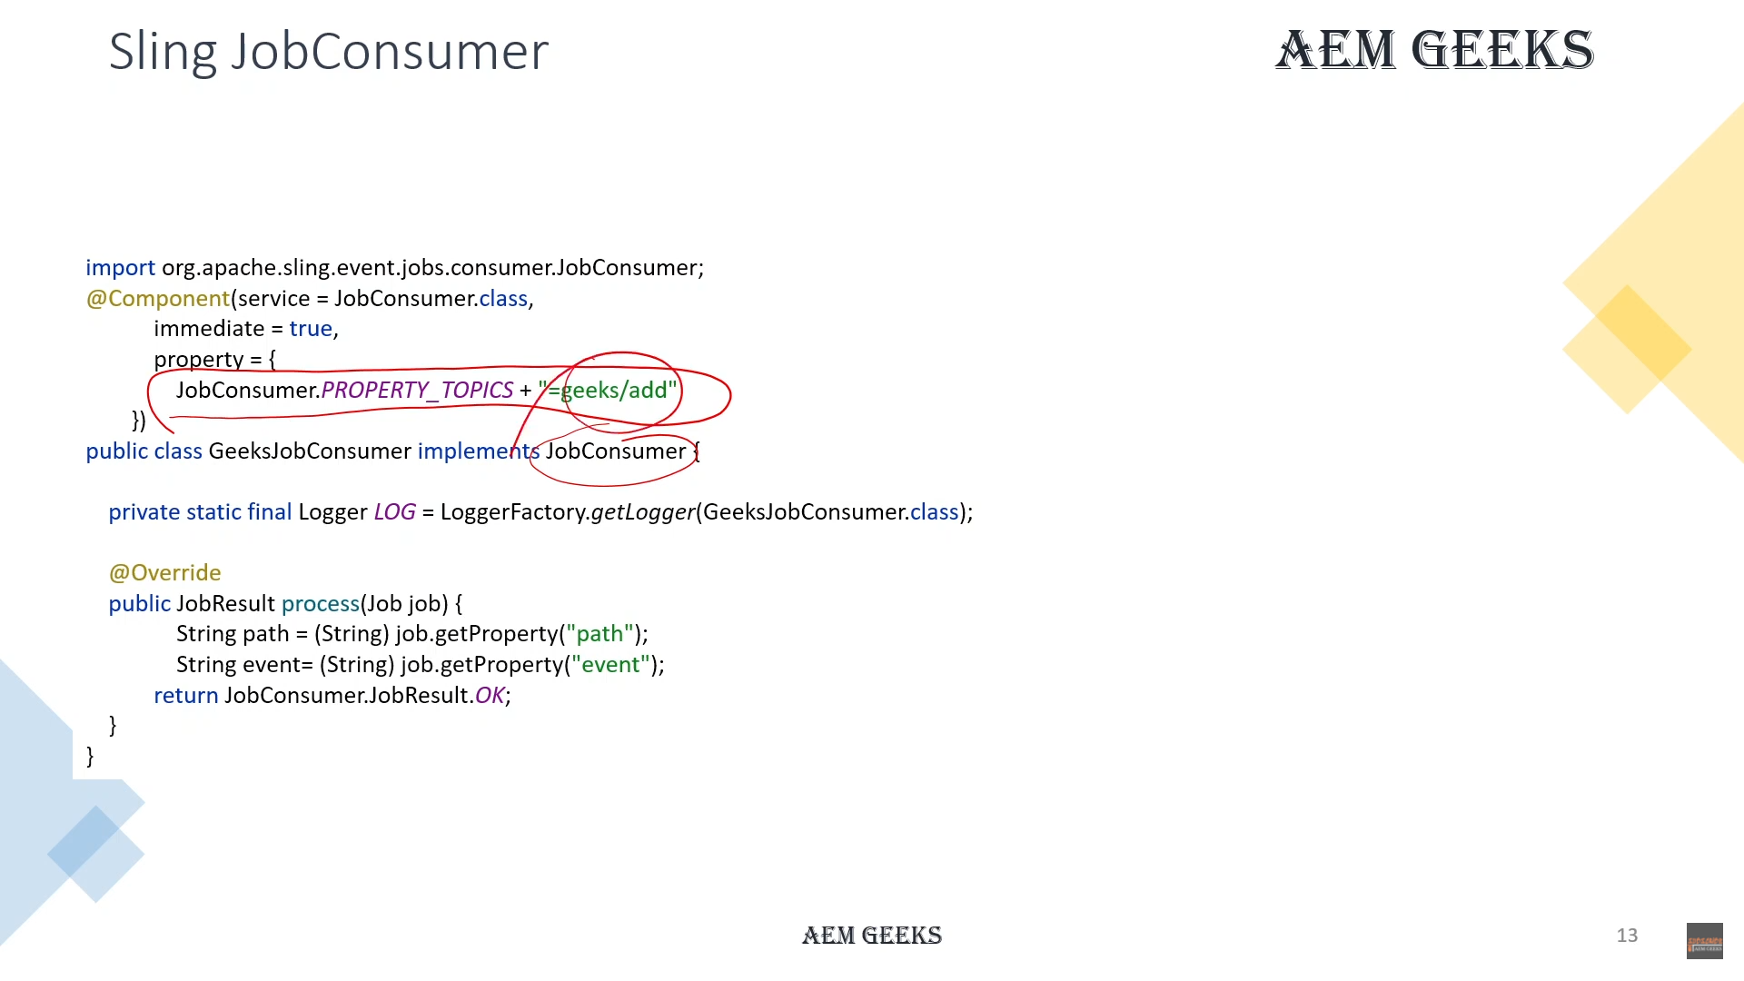

# Event Handling JCR Api

# Event Handling OSGi Api

# Event Handling Sling APi

# Event Handling #5 Guaranteed event processing with JobManager and JobConsumer

# Event Handling #6 Replication Event Handler in AEM

# Event Handling #7 Event Handling for page actions in AEM

# Context Aware Configuration in AEM

# Install multiple packages without package manager in aem

# JCR SQL2 #1 JCR SQL2 query in aem

# JCR SQL2 #2 JCR SQL2 Java API in aem

# FolderStructure

# Slightly – data sly list - map

# System User

# Query Builder #1 | Query Builder query in aem

# Query Builder #2 | How to write Query Builder query in aem

# Query Builder #3 | Pagination with Query Builder query in aem

# Query Builder #4 | Query Builder Java API in AEM

# AEM Workflow

# Create Workflow model and Launcher in aem

# Trigger Workflow using API in aem

# Custom Workflow Process in aem

# Custom Workflow Step with dialog in aem